Equbal Fahmi 12018038

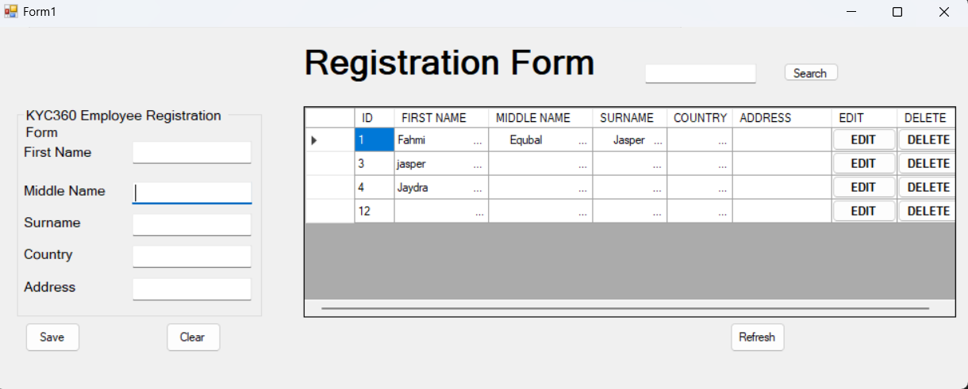

Solution Description:

1. Features:

The project aims to provide a comprehensive solution for managing student registration and enrollment. Key features include:

- Add, Edit, Delete Records: Users can easily add new student records, update existing ones, and remove unnecessary entries, providing flexibility and control over the database.

- Search Functionality: The system offers a search feature that allows users to find student records quickly by name, enhancing efficiency in data retrieval.

- SQL Server Integration: Utilizing a SQL Server database backend ensures data persistence and reliability, enabling seamless CRUD operations and efficient data management.

- Responsive User Interface: The application employs Windows Forms to create an intuitive and user-friendly interface, promoting ease of use and accessibility for users.

2. Technologies Used:

The solution leverages several technologies to achieve its objectives:

- C: The primary programming language for implementing the application logic and user interface design.

- .NET Framework: Provides the necessary framework for building Windows Forms applications in C, offering robust development capabilities and platform support.

- SQL Server: Selected as the backend database management system for storing and managing student records, offering scalability, reliability, and robust data management features.

- Windows Forms: Chosen for building the graphical user interface (GUI) of the application, facilitating the creation of interactive and responsive desktop applications.

3. Approach:

Database Design:

The first step involves designing the database schema to store student records efficiently. This includes defining tables, relationships, and constraints to ensure data integrity.

CREATE TABLE Students (

StudentID INT PRIMARY KEY,

FirstName VARCHAR(50),

LastName VARCHAR(50),

DateOfBirth DATE,

ContactNumber VARCHAR(15),

Email VARCHAR(100),

Address VARCHAR(255)

);

User Interface Design:

Using Windows Forms, design the user interface to provide a seamless and intuitive experience for users. This involves creating forms, controls, and layouts to interact with the database.

// Code to add a new student record

private void btnAdd_Click(object sender, EventArgs e)

{

string firstName = txtFirstName.Text;

string lastName = txtLastName.Text;

}

Database Operations:

Implement CRUD operations (Create, Read, Update, Delete) to interact with the database. Use SQL commands or an Object-Relational Mapping (ORM) framework like Entity Framework for data manipulation.

// Code to retrieve student records from the database

private void LoadStudents()

{

string query = "SELECT * FROM Students";

// Execute SQL query and populate data grid

}

Search Functionality:

Implement search functionality to enable users to search for specific student records based on criteria such as name, ID, or other attributes.

// Code to search for students by name

private void SearchStudents(string keyword)

{

string query = $"SELECT * FROM Students WHERE FirstName LIKE '%{keyword}%' OR LastName LIKE '%{keyword}%'";

// Execute SQL query and display results

}

Reasoning:

- Technology Selection: The chosen technologies, including C, .NET Framework, SQL Server, and Windows Forms, were selected based on their compatibility, familiarity, and suitability for building desktop applications with robust database functionality.

- User-Centric Design: The user interface design prioritizes usability, with intuitive forms and controls to facilitate smooth interaction and minimize user errors.

- Database Efficiency: The database schema is designed to optimize data storage and retrieval, ensuring efficient CRUD operations and data integrity.

- Scalability and Maintainability: The solution is built with scalability and maintainability in mind, allowing for future enhancements, updates, and integration with additional features or systems.

Overall, the approach focuses on delivering a reliable, user-friendly, and efficient solution for managing student registration, leveraging the capabilities of modern technologies and best practices in software development.